Cellular Division Via Mitosis
Student Name
Institutional affiliation

Title: Cellular Division Via Mitosis
Introduction
All living cells posses the ability of dividing which makes them increase in number and prevent their extinction. There are two cell vision in eukaryotic namely karyokinesis and cytokinesis. The division of cells through meiosis or mitosis is known as karyokinesis while the division of cytoplasm is cytokinesis.
The core component of the nucleus is the chromosome as it carries the hereditary information. There is duplication of the chromosomes during the growth cycle of the cell, interphase. Sister chromatids are the two identical strands of DNA (Buschmann & Zachgo, 2016). The process of the cell sorting the nuclear contents with the inclusion of sister chromatids is termed as karyokinesis. Animal cells, the division of the cytoplasm is through the process of furrowing which is the constriction of the cell membrane. Two independent daughter cells are formed when the contracting ring eventually pinches the cell. On the other hand, there is creation of the cell plate in plants for the division of the cytoplasm to occur (Schaefer et al., 2017). The cell plate forms in the in the middle of the cell resulting in the creation of two different daughter cells.
In the growing embryonic tissue, mitosis is most visible as there is more division of cells at the same time. The early embryonic phase in the development of the Whitefish egg is known as the Whitefish blastula. There are blastula cells in the variety of stages in the cell cycle as the cell division is not well synchronized.
Objectives
The lab report focuses on attaining the following objectives;
Identification of the stages of mitosis in both animal and plant prepared cell slides.
Staining of the chromosomes of the dividing tissues of plant.
Identification of the number of chromosomes in the onion’s cultivars.
Formulation of hypothesis through the use of descriptive statistics and chromosome counting techniques
Materials and methods
Methods
Part I
A prepared slide of Whitefish blastula was obtained and observed under the scanning power in the microscope. The cells which contained dark colored chromosomes were viewed and the different stages of mitotic stages identified. since there were several sections on the slide that contained many cells if there was no stage which was observed in one section, we moved to the next one. The examples of prophase, anaphase, interphase, telophase and metaphase were found. The stages were identified and well labelled.
Part II: Mitosis in Plant Cells
The root tip is an example of growing tissues that has an increased rate of mitosis. There is division of the cells behind the root tip which enables the elongation of the root.
A prepared slide of a longitudinal section of the onion root tip was obtained. There was identification of the different stages of division, prophase, interphase, telophase and metaphase in the cells behind the root tip. Each phase of the cell division was illustrated.
Part III: Comparison of the length of time spent in each phase of mitosis
A time of ninety minutes is taken in the division of the cells of an onion. This information was utilized in estimation of the time required in each phase of cell division.
There was observation of forty dividing root tip cells of the onion and the number observed were recorded in a table. The percentage of cells in each phase were noted through division of the total number of the observed cells with forty. As the frequency of appearance has a direct correlation with the phase length it was multiplied with the cells in a phase and times with the total length of mitosis for the estimation of the length that is spend by a cell in each phase of mitosis.
Part V: Testing of hypothesis
There is a need of differentiation of differentiation of strains of onion from Sprout Incorporated with The Green Thumb Corporation as there is pending lawsuit that the latter has stolen the strain. The Sprout incorporated strain has diploid number of eighteen chromosome and the Green Thumb Corporation number of chromosomes have to be identified to note whether there is infringement of the patent.
There was selection of a cell on the prepared slide that had chromosome better spread through squashing and the cells which were under mid and late anaphase were utilized. The number of chromosomes were counted and recorded in a table. The number of chromosomes on the second pole were counted and then compared to the original count. This was repeated until all the cells were counted.
Results
Part I
Figure 1: Interphase and anaphase as observed under light microscope
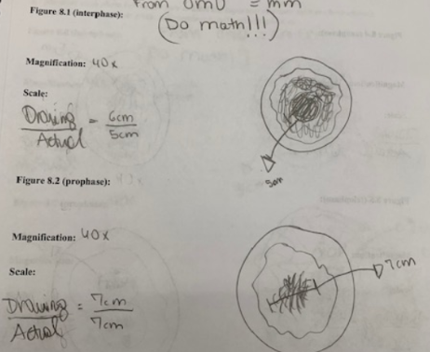
Figure 2: showing interphase, anaphase and telophase of the Whitefish blastula
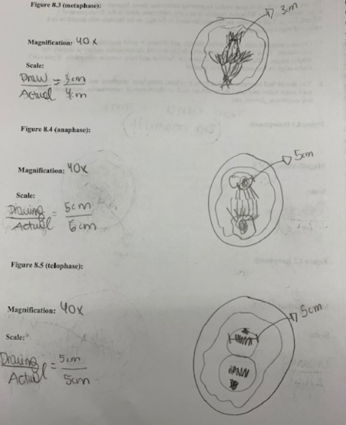
There was observation of more dividing cells on the inside of the cells rather than the periphery of the blastula.
Part 2: Observation of the division of the root tip plant cells
Figure 3: showing plant cell interphase and prophase
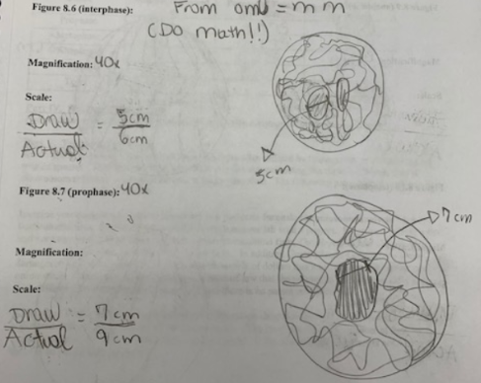
Interphase
Prophase
Figure 4: showing metaphase, anaphase and telophase of the plant cell division
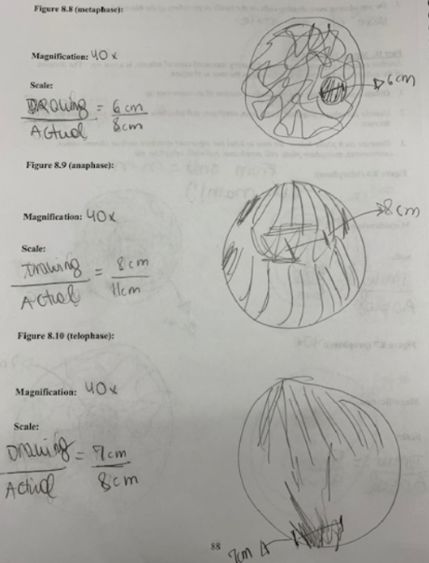
Part III
Phase | Number Observed (A) | Percent of Total (B)=A/40 | Length (Min) B x 90 min
Prophase | 15 | 0.375 | 33.75
Metaphase | 11 | 0.275 | 24.75
Anaphase | 4 | 0.125 | 11.25
Telophase | 9 | 0.1 | 9
Total

Table 1: showing the result for calculation of time of division in onion tap root cells
It was observed that the longest phase of division was prophase.
Part V
Table 2: showing the number of chromosomes observed in ten cells
Cell number | # chromosomes observed
1 | 10
2 | 7
3 | 7
4 | 7
5 | 9
6 | 9
7 | 11
8 | 9
9 | 9
10 | 10

There was variation in the number of chromosomes counted regardless of each species having a constant number of chromosomes as there are variation depending on the nucleus.
Part VI: Testing of hypothesis; Analysis of class data
Table 3: Observation of the number of chromosomes observed in a species
Number of chromosomes (A) | Number of cells observed (B) | A x B (C) | (A-average)2 (D) | B (A-average)2 (E)
4 | 1 | 4 | 25 | 64
5 | 3 | 15 | 16 | 36
6 | 16 | 96 | 9 | 49
7 | 23 | 161 | 4 | 196
8 | 35 | 280 | 1 | 676
9 | 30 | 270 | 0 | 441
10 | 27 | 270 | 1 | 324
11 | 10 | 110 | 4 | 1
12 | 13 | 156 | 9 | 16
13 | 5 | 65 | 16 | 16
14 | 4 | 56 | 25 | 25
15 | 0 | 0 | 36 | 81
16 | 2 | 32 | 49 | 49
17 | 1 | 17 | 64 | 16
18 | 0 | 0 | 81 | 18
19 | 0 | 0 | 100 | 81
20 | 0 | 0 | 121 | 81
Column | 170 | 1532 |  | 870

Average =Sum from column C divided by sum from column B
=1532/170
=9.011764706
=9
Variation =sum from column E divided by sum from column B minus one
=E/(B-1)
=1532/ (870-1)
=1532/869
=1.762945915
Standard deviation
=squared root of variation
=1.327759735
Despite the chromosome number being constant for a specific species, the counted chromosomes vary due to factor such as different mutation.

References
Buschmann, H., & Zachgo, S. (2016). The evolution of cell division: from streptophyte algae to land plants. Trends in Plant Science, 21(10), 872-883.
Schaefer, E., Belcram, K., Uyttewaal, M., Duroc, Y., Goussot, M., Legland, D., ... & Bouchez, D. (2017). The preprophase band of microtubules controls the robustness of division orientation in plants. Science, 356(6334), 186-189.

